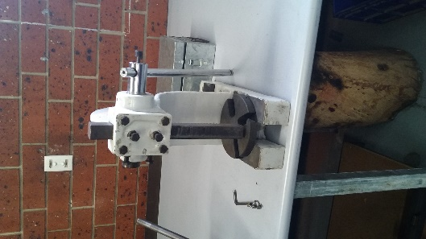
Plant Risk Assessment
Arbor Press

Ref No: (e.g. Asset or Purchase Number) |  | 2 Ton Arbor Press | Site
Date of assessment: |  |  | Department/Area:
Identify/describe activity, equipment you are assessing: The use of a 2 Ton Arbor Press

Item | Step 1: Identify the hazard/s:  A hazard can be defined as a source or a situation with a potential for harm in terms of human injury or ill-health, damage to property, damage to environment, or a combination of these | Step 2: Assess the risks:  When conducting a risk assessment YOU MUST consider what could happen if someone is exposed to a hazard (consequences), the likelihood of it happening and how long the worker is exposed to the hazard. | Step 3 & 4: Reducing the risk:  What are the most suitable controls to reduce the risk?  Use ‘Hierarchy of Control’ from top down and combine multiple controls if needed to reduce risk to as low as reasonably practicable.  Hierarchy of controls  Level 1: – Eliminate the hazards  Level 2: – Substitute the hazard with something safer  Level 3: – Reduce the risk through engineering controls  Level 4: – Reduce the exposure to the hazard through administrative controls  Level 5: – Use personal protective equipment | Step 5: Monitor & review:  How will the risk be monitored and who has the responsibility? Record review date

Item No. | What could cause harm?  (Refer to the “What Could Cause harm” document in the Resources Tab on the CSH&W Website) | What could go wrong?  (Refer to the “What Could Go Wrong” document in the Resources Tab on the CSH&W Website) | Controls | Additional Controls | Date Complete | Review method & position/ person responsible | Review  Date
 | Manual operation of the Arbor Press | Nipping, trapping, crushing of worker/students fingers or hand  Worker/student could receive an injury from objects ejecting from the press whilst under pressure  Handle could strike a worker/student  Worker injured while conducting maintenance on the plant | Workers/students are adequately trained in the hazards and safe operation of the plant  Regular workplace inspections are conducted  Worker/students are provided with personal protective equipment (PPE)  There is a safe operation procedure for using the plant  Workers are trained in plant maintenance
 | Noise (working in the workshop) | Potential hearing loss/impairment  Workers/students cannot communicate due to noise | PPE is available on request  Workers/students are trained on the dangers of workplace noise
 | Manual Handling of the plant and moving product on/off the plant | Bending/stooping to pick up products  Moving projects on/off the Arbor Press | Plant is set at a suitable height to minimise stooping  Trolleys are available for moving items if required  All workers and students are trained in safe manual handling techniques

Review hazard/risk assessment if task or circumstances change and at intervals appropriate to the level of risk (minimum 5 years).

Completed by (name): Signature: Date:

In consultation with (name): Signature: Date:

Risk Assessment Authorised by: Signature: Date:

REVIEW/FEEDBACK Please circle Yes or No
Were the controls effective | YES | NO | Were there any unforeseen hazards or issues | YES | NO | Were there any incidents | YES | NO
DETAILS |  |  | DETAILS |  |  | DETAILS

The following section is to be completed after the completion of task or activity.

NAME: SIGNATURE: DATE:

