Waste Discharge Guideline
The following guideline is designed to assist sites to identify what waste discharge collectors, e.g., grease pits, acid traps, neutralisers etc. that may or should be in place and what is required for ongoing operation and service (maintenance), particularly regular cleaning / pumping out.

Service Frequency
Your service frequency is set based on the type of pre-treatment device you have, what kind of contaminants and their loadings that you may be discharging to the device, and your onsite processes. The frequency of cleaning / pumping should be detailed on your authorisation from SA Water or local council in some regional areas e.g., the Riverland & Mt Barker. SA Water’s Trade Waste officers regularly assess this frequency during audits and can adjust it based on the levels of contaminants present compared to your current service dates. Details of how often you should have your device serviced should be identified in the relevant section of your authorisation to discharge trade waste document from SA Water or local Council (where applicable). SA Water advise having a scheduled contract with your service agent to ensure you do not miss any services. SA Water’s system (relevant to the areas SA water manage) will also automatically remind you when your service is due or if you have missed any services. In other areas e.g., the Riverland, the local Council may do this. There may be penalties for any non-compliance with the service frequency. It is also advisable to make sure your contractor is properly servicing the device: contents must be fully removed, and residues scraped from the device walls. Some contractors keep time-stamped photographic records of the service which they can supply as evidence of this work being completed.
Note: If your current authorisation to discharge from SA Water or local Council (where relevant) is over 10 years old or you cannot locate it, please contact SA Water (contact details below) or the local Council (if relevant) to arrange for an audit / inspection to determine your frequency for servicing (cleaning/pumping out).
tradewaste@sawater.com.au / 08 7424 1336
Schools and Childminding
Wastewater from schools and childminding training activities such as food preparation, laboratories and art contain grease and suspended solids at concentrations or quantities greater than a typical household but lower than dedicated business processes for similar activities. This material can still be corrosive or generate foul odours and build up in sewer pipes, restricting flows and causing blockages. Appropriate management practices at each site are necessary. This applies to but is not restricted to the following activities:
• School training kitchens
• School training laboratories
• School Art/ pottery Classrooms
• School Mechanical classrooms
• School outdoor/ nature classrooms
• School Swimming Pools
• School Animal, Agricultural classrooms

This information does not apply to childcare centre kitchens, school tuckshops, canteens/cafeterias and tertiary education training kitchens. These activities should reference the Commercial Food Preparation and Service Fact Sheet from SA Water (link detailed below). This Fact Sheet does not apply to University and Tertiary education Laboratories. The SA Water Laboratories and clinical practices fact sheet (link detailed below) will apply in this application. This Fact Sheet does not apply to School Groundskeeping and maintenance facilities. The SA Water Vehicle Washing and Bunding and Blind Tanks guidelines should apply (link detailed below).
Key Trade Waste Quality Requirements
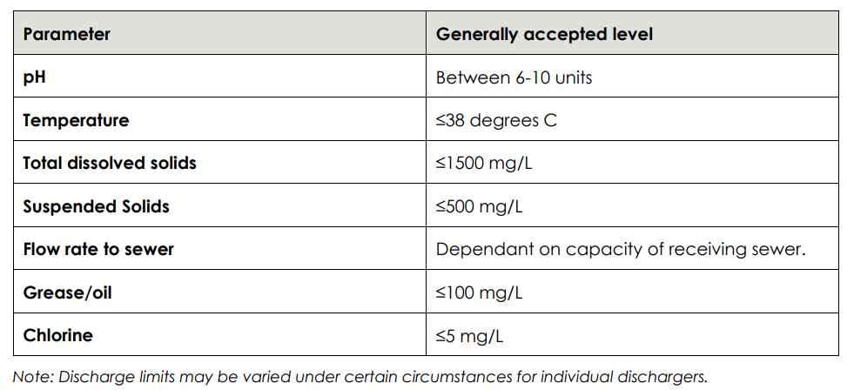

School / College Training Laboratories
School training laboratories are used less frequently and utilise lower concentration chemicals than standard laboratories. Pre-treatment is required to be installed.
• The Laboratory and Clinical practices fact sheet (link below) is to be referenced with the disposal and containment of chemicals.
• Primary School Laboratories do not require a neutraliser to be installed. All sinks should discharge through a 225 mm silt trap fitted with mesh basket or holed bucket with 3 mm mesh/hole size, including a fixed secondary strainer with a max 3 mm hole size.
• All Secondary School laboratories require a neutraliser to be installed and sized by the following criteria: o Lab sinks sized at 30 Litres per hour.
o Minimum school laboratory neutralizer size is 400 L.

School Training Kitchens / Large Canteens
School training kitchens are used less frequently than standard commercial kitchens and replicate domestic cooking environments. Due to the increased risk to sewer than usual domestic cooking and cleaning, pre-treatment is required to be installed.
• Waste strainer basket (maximum 3 mm holes) with a fixed secondary strainer (maximum 3 mm holes) installed at sink outlets.
• Floor waste fittings with a water seal in the work area are fitted with a strainer basket (maximum 3 mm holes) and a fixed secondary strainer (maximum 3 mm holes).
• Grease Arrestor to be sized as per the methods in the Commercial Food Preparation and Service Fact Sheet (link below), but with the following amendments:
o Single bowl sinks 30 Litres per hour, Double bowl sinks 60 Litres per hour.
o No retention capacity is required for floor wash down.
o Dishwasher 30 Litres per hour.
o Overall risk rating is Low and therefore storage factor is 1.
o Minimum School classroom grease arrestor size is 1000 L.

School / College Art, Outdoor STEM and Nature Play Classrooms
School and childcare centre art, outdoor STEM classrooms generate wastewater that may contain traces of paint, clay and other suspended solids that may harm the sewerage system.
• Waste strainer basket (maximum 3 mm holes) with a fixed secondary strainer (maximum 3 mm holes) installed at sink outlets.
• Where large solids are present wastewater discharges via a 225 mm silt trap fitted with mesh basket or holed bucket with 3 mm mesh/hole size, including a fixed secondary strainer with a max 3 mm hole size.
• If suspended solids (particles that would pass through a 3 mm screen) are present, wastewater discharges via a suitably sized, approved settling tank or pit.
o Sinks are sized to 30 Litres per hour.
o Art troughs are sized to 30 Litres per hour for the first water outlet, and 15 L per hour for subsequent water outlets.
o A single sink may discharge to an approved plaster trap.
o Art Classrooms may discharge through a shared Neutraliser or a Grease Arrestor that is appropriately sized for the combined flow.
o The minimum size of an art classroom settling pit is 400 L.
• Oil based paints and solvents must not be poured into sinks or discharged to the sewerage system. These products are to be contained and disposed off-site.
• Wastewater-based paint may not be discharged to the sewerage system. Rinsing of jars and brushes containing minor amounts of water-based paint is acceptable.
• Outdoor sinks must be positioned undercover to prevent the ingress of wind driven rain/stormwater. Cover must have a minimum overhang of 1 metre but at least one third of roof height is provided, to prevent the intrusion of wind driven rainfall. Where such an overhang is impractical, walls are used.

School/ College Mechanical Classrooms
School mechanical classrooms generate wastewater that may contain traces of oil, hydrocarbons and suspended solids that may harm the sewerage system.
• Waste oil, degreaser and solvents are to be stored in blind containers for disposal off site at an EPA Licenced facility.
• All oils, fuels, concentrates and chemicals should be contained within an impervious bund designed to the Bunding and Blind Tank fact sheet.
• Only quick break detergents/degreasers are to be used.
• Waste strainer basket (maximum 3 mm holes) with a fixed secondary strainer (maximum 3 mm holes) installed at sink outlets.
• Floor waste fittings with a water seal in the work area are fitted with a strainer basket (maximum 3 mm holes) and a fixed secondary strainer (maximum 3 mm holes).
• All floor drainage, channels and washdown sinks are to discharge through an approved 1000 L/h oil separator installed to the Vehicle Washing Fact Sheet.

Swimming Pools
Trade waste discharges from school swimming pools could harm the sewerage system and pose a similar risk to that of commercial swimming pools. Discharges contain contaminants, which can exceed the Restricted Wastewater Acceptance Standards. The Swimming pool Fact Sheet should be referenced; in particular:
• Small, regular discharges, such as wastewater arising from the backwashing/cleaning of filters and water treatment devices and overflows due to rain are directed to sewer at ≤ 0.5 litres per second.
• Discharges greater than 20,000 litres not specifically covered by a trade waste discharge authorisation must follow the Non-domestic Liquid Hauled Waste guideline. Non-domestic hauled waste charges apply for these discharges.
• Appropriate pre-treatment facilities may be required to achieve compliance with discharge quality limits.
• An annual stormwater acceptance fee will apply to uncovered school swimming pools. The current fee can be found on the Trade Waste Fees and Charges fact sheet.

Animal, Agricultural and Horticultural Classrooms
Animal, Agricultural, and horticultural classrooms, and washdown facilities generate wastewater that may contain large amounts of suspended solids and organic materials that may harm the sewerage system.
• Waste strainer basket (maximum 3 mm holes) with a fixed secondary strainer (maximum 3 mm holes) installed at sink outlets.
• Floor waste fittings with a water seal in the work/ wash down areas are fitted with a strainer basket (maximum 3 mm holes) and a fixed secondary strainer (maximum 3 mm holes).
• All solids (faeces, straw, hair/fur, food scraps, bedding etc) are collected before wash down of any animal enclosure and disposed of via a solid waste/manure bin.
• Solid waste/manure bins are designed or located to exclude stormwater/rainwater.
• All wash down areas are:
o Constructed of impervious material, with a minimum 1:80 gradient to drain point.
o Bunded and roofed to contain wash water and exclude rainwater from sewer. Walls may be employed, but where sides are left open, a minimum roof overhang of 1 metre for every 3 metres of height is required.
• If suspended solids (particles that would pass through a 3 mm screen) are present, wastewater discharges via a suitably sized, approved settling tank or pit. The minimum size of an Animal classroom settling pit is 1000 L.

More information
Mains Water Protection (AS/NZS 3500.1:2015)
Grease Arrestor Maintenance: Guideline for Trade Waste Customers - SA Water
Backflow Prevention Requirements - Office of the Technical Regulator
Restricted Wastewater Acceptance Standards - SA Water
Stormwater Management - EPA
Waste Guidelines and Fact Sheets - SA Water
Trade Waste Fees and Charges - SA Water
tradewaste@sawater.com.au / 08 7424 1336
Note: Further guidance if required can be sought from your allocated CSH&WSA WHS Consultant.

