Cricut Machine |  |  |  | SOP Number: | RA Number:
 |  |  |  | 096SOP | 116RA
DO NOT use / operate this equipment or complete the task unless you have been trained.
POTENTIAL RISKS: Electricity, High Temperatures, Sharp blade
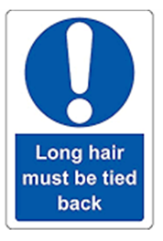 | 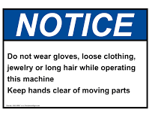 | 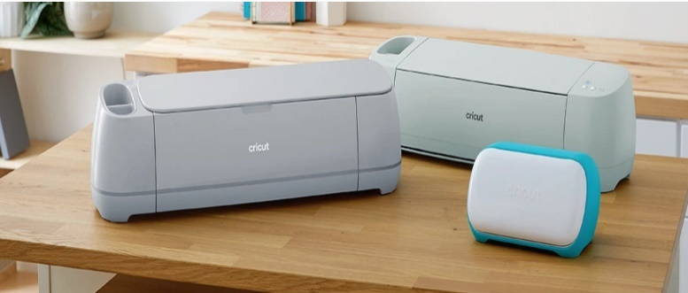

PRE-OPERATIONAL SAFETY
- Check for obvious faults and defects. Check the item has a current electrical test tag attached. Faulty equipment must not be used. Immediately report it.
- Ensure the risk assessment has been completed.
- Ensure no slip / trip hazards are present in the workspace and walkways.
- Locate and ensure you are familiar with the operation of the ON/OFF switch.
- Ensure the room is well ventilated with circulating air.
- Cricut is located on a level, stable surface.

OPERATIONAL SAFETY PRECAUTIONS
- To be used as per manufacturer’s operating instructions only
- Use with Cricut attachments only
- Never place your fingers or other objects inside the unit while connected to power, or while the machine is powered on, or during cutting operations
- Cutting blade will need to be replaced occasionally. Care must be taken when changing the cutting blade and this is only to be completed by a staff member
- Storage of equipment and accessories (spare blades and cutters) must be clearly labelled and stored away
- Work Area - Place Cricut Machine on a flat and stable surface. Make sure your workspace has sufficient space in the front and back of the machine to allow the cutting mat to move through the cutting Machine.
- Do not use if item is damaged or jammed
- CAUTION: Should the equipment need inspection – always turn off power supply and remove plug from power point.

HOUSEKEEPING
- Disconnect the electrical power when not in use by unplugging the power cord for the outlet.
- Service and inspect as per manufacturer’s instructions.
- Always unplug machine before replacing the blade. Blades are extremely sharp and should be handled with caution and extreme care.
- Only clean the machine with a soft cloth dampened with glass cleaner or water. Never use any kind of flammable liquid to clean the machine. Do not use solvents such as acetone or nail polish remover to clean the machine
- Leave the machine and work area in a safe, clean and tidy state.
- Dispose of waste material appropriately.
Date of last review: |  |  | Signature:

