Dealing with Bodily Fluids |  |  |  |  |  | SOP Number: |  | RA Number:
 |  |  |  |  |  | 092SOP |  | 110RA
DO NOT use / operate / this equipment or complete the task unless you have been trained.
POTENTIAL RISKS: Blood borne virus, infections
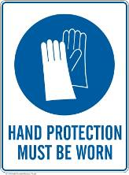 | 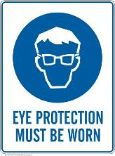 | 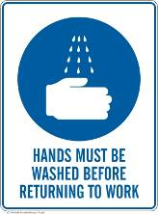

PRE-OPERATIONAL SAFETY
- Standard precautions are recommended in the handling of:
- blood, including dried blood
- all other body substances including saliva, urine and faeces, regardless of
whether they contain visible blood
- broken skin
- mucous membranes (lining of nose, mouth and genitals)
Standard precautions are good hygiene practices relating to hand hygiene, the use of gloves and other protective clothing (as appropriate), and the safe disposal of waste

OPERATIONAL SAFETY PRECAUTIONS
SURFACE CLEANING OF BLOOD & BODY SUBSTANCES
If the blood or body fluids are spilled on surfaces, the following cleaning procedures must be followed:
1. Deal with the spill as soon as possible.
2. Protect yourself by wearing disposable rubber gloves. Eye protection and a plastic apron should be worn where there is a risk of splashing.
3. Remove as much of the spill as possible with paper towel.
4. Clean area with warm water and detergent, using a disposable cleaning cloth or sponge.
5. The area should be left clean and dry.
6. Disinfect the area with a solution of household bleach, diluted according to the manufacturer’s instructions.
7. Remove and dispose of gloves, paper towel, and cleaning cloth in a sealed plastic bag after use. The plastic bag may then be thrown away with normal waste.
MANAGING EXPOSURE TO BLOOD OR OTHER BODY SUBSTANCES
Wash hands thoroughly with soap and warm water.
- If any person has contact with blood or body fluids, the following procedures should be observed:
- Remove contaminated clothing
- If blood or body fluids gets on the skin, irrespective of whether there are cuts or abrasions, wash well with soap and water.
- If the eyes are splashed, rinse the area gently but thoroughly with water while the eyes are open.
- If blood or body fluid gets in the mouth, spit it out and rinse the mouth with water several times, spitting the water out each time.

HOUSEKEEPING
- All incidents must be reported immediately to your Manager/WHS Coordinator.
Date of last review: |  |  |  | Signature:

Acknowledgement much of the information in this document has been sourced by the Department of Education & Children’s Services SA.

