Fragile Roofing
Fragile roofing is a major contributing factor in multiple serious injuries and deaths across Australia every year. Workplaces must ensure that fragile roofing, if in place, is appropriately managed to ensure injuries to workers are eliminated and our worksites do not become part of these statistics.
All roofs should be treated as fragile until a competent person has confirmed they are not. No roofing, no matter what the material, should be relied on to bear the weight of a person, unless it has been specifically engineered and manufactured to achieve this. This includes the roof ridge and purlins.
Roofs are likely to be considered ‘fragile’ if they are constructed of the following materials:
- asbestos roofing sheets
- polycarbonate or plastic commonly used in skylights
- polycarbonate sheets commonly used on pergolas, verandahs, sheds etc.
- roof lights, particularly those in the roof plane that can be difficult to see in certain light conditions or when hidden by paint
- fibre cement sheets
- liner panels on built-up sheeted roofs
- metal sheets and fasteners where corroded
- glass, including wired glass
- chipboard or similar material where rotted
- wood slabs, slates and tiles
Protection must be provided if there is a risk of falling through the roof and work is being done on the top of the roof. Control measures to prevent injury from work on or near fragile roofs are similar to methods used for roof work more generally, including using:
- an elevating work platform so workers can avoid standing on the roof itself
- barriers such as guard rails or covers that are secured and labelled with a warning
- guard rails fitted to all work and access staging or platforms
- walkways or crawl boards of a suitable size and strength
- staging on the roof surface to spread the loads
- safety mesh secured under fragile roofing or skylights. If safety mesh is used, ensure it:
- conforms to AS/NZS 4389:2015 Roof safety mesh
- is installed by a competent person in a safe manner and in accordance with the manufacturer’s instructions
- has its integrity inspected by a competent person prior to roof maintenance or removal
- is covered by the roof cladding as soon as reasonably practicable after it has been installed
The mesh should be formed from minimum 2 mm diameter wire, welded into a mesh with the longitudinal wires not more than 150 mm apart and the cross wires not more than 300 mm apart. Transverse wires should have a 450 MPa minimum tensile strength and longitudinal wires a 500 MPa minimum tensile strength.
- a harness system with adequate anchorage points etc., along with appropriate training and supervision. Additional trip hazards are created by wearing harnesses – workers need to be aware of taking extra care with their use. The training should include how to rescue someone who falls while using a fall arrest system.

Safety mesh is not required where one or more of the following conditions exist (AS 1562.3:2006):
- The roof makes an angle to the horizontal as follows:
- Class 2 to 9 buildings, as defined by the Building Code of Australia, 40⁰ or more
- Class 1 and 10 buildings, as defined by the Building Code of Australia, 30⁰ or more
- There is a substantial and closely boarded floor or similar structure below the roof at a vertical distance of not more than 3 m measured from the highest point of the plastic sheet incorporated into the roof.
NOTE: The above implies that safety mesh may only be applicable to those parts of the roof that are over 3 m above a closely boarded floor or similar structure (that is, only part of the roof may require safety mesh)
- There is a raised single arch profile of overall height not less than 100 mm from the base support line. Both female side-lapping ribs are fixed over the supporting male underlapping ribs on either side for the entire length of the sheet, and the resultant effective cover width is not greater than 450 mm.
- The roof sheet has an effective cover width not greater than 300 mm, and a matching metal sheet is located on either side to support the plastic sheet throughout its entire length.
- The rafters supporting the roof are not more than 300 mm apart.
- For Class 1 and 10 buildings (Building Classifications), as defined in the Building Code of Australia, where a roof or a model of the roof passes the resistance to impact test (sand bag test) specified in Clause 5.4 and the plastic roofing material is not being used as an insert surrounded by the main roofing material with each insert being less than 60% of the length of the adjacent roofing material.
- For Class 2 to 9 buildings (Building Classifications), as defined in the Building Code of Australia, where a specific roof lifetime is claimed and the roof sheet durability against the resistance impact, as defied in Clause 5.4, has been demonstrated for the same period of time.
- Where the sheet is installed as a single skylight, which has been manufactured in accordance with AS 4285.
Roofing Sheets that have passed the sand bag test:
- Danpalon is a polycarbonate product that allows light through and has been sand bag tested, which means it does not require mesh to be installed below it. (Refer photo below). Further information is available from Polycarbonate Light Architecture Solutions | Danpal.
- Ampelite Webglass GC and GC+ is a fibreglass product that allows light through and has been sand bag tested, which means it does not require mesh to be installed below it. (Refer photo below). Further information is available from Ampelite Australia – Fibreglass and Polycarbonate roofing supplier.
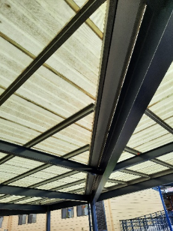
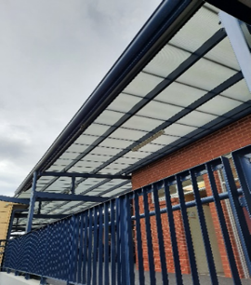
Note: While mesh is not required, neither of these products have been designed to be walked on.

Danpalon installed (no mesh required) Ampelite Webglass installed (no mesh required)
Actions required by Worksites:
- Identify if ‘fragile roofing’ is in place at your worksite/s (your WHS Consultant can assist).
- If yes, complete a risk assessment (your WHS Consultant can assist).
Worksite Considerations:
- If undertaking new construction / development or refurbishment work and roofing materials require light to pass through them, Danpalon or Webglass should be considered over standard polycarbonate.
- If undertaking new construction / development or refurbishment work, the design of structures should be such that the need for persons to access roof areas is eliminated or significantly minimised.
- Plant and equipment should be located at ground level (where possible) to reduce the need for persons to be on roofs in the first place.
- If plant and equipment has to be located on roofs, then these will require ease of access and dedicated walkways, along with fall prevention infrastructure e.g. rails, anchor points, dedicated ladder access points etc.
- If workers have to access roofs, then a range of actions are required to prevent / minimise falls from heights.
Further Information / Guidance:
- Contact your WHS Consultant
- CSHWSA - Fall Prevention Procedure
- Approved Code of Practice - Managing Risk of Falls at Workplaces
- Safe work on roofs - Information sheet | Safe Work Australia
- Polycarbonate Light Architecture Solutions | Danpal
- Ampelite Australia – Fibreglass and Polycarbonate roofing supplier
- Fall Protection Systems - Height Safety & Fall Arrest Solutions (correctsafety.com.au)
- Home | RISsafety
- Adelaide Height Safety Adelaide
- Understanding the National Construction Code – Building Classifications (abcb.gov.au)
- AS 1562:2006 – Design and Installation of Sheet Roof and Wall Cladding, Part 3: Plastic
- AS/NZS 1562:2006 – Design and Installation of Sheet Roof and Wall Cladding, Part 2: Corrugated fibre-reinforced cement
- AS 4285:2019 – Rooflights (skylights)
- AS/NZS 4389:2015 – Roof Safety Mesh
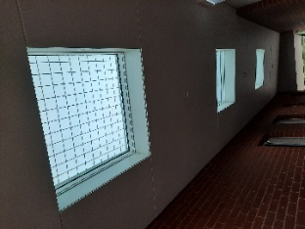
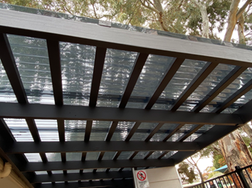

Skylight with mesh installed Additional beams installed (max 300 mm apart)

