Event Emergency Management Plan

INSERT NAME OF EVENT
DATE OF EVENT

Contents
1. INTRODUCTION 3
2. COMMAND & CONTROL 3
3. RESPONSIBILITY OF INDIVIDUALS / AGENCIES 4
4. ALLOCATION OF RESOURCES 4
5. COMMUNICATIONS 4
6. INSURANCE 4
7. LOST / FOUND PERSONS: 4
8. LOST / FOUND PROPERTY: 4
9. EMERGENCY PROCEDURE / EVACUATION PLAN 4
10. TRAFFIC MANAGEMENT PLAN / VEHICLE MANAGEMENT 5
11. SITE PLAN 6
12. INCIDENT MANAGEMENT PLAN 8
13. MEDIA 9
14. APPENDICES 10
14.1. Appendix 1: Emergency Response Procedure 10
14.2. Appendix 2: Traffic Management Plan 11
14.3. Appendix 3: Incident & Investigation Report Form 12
14.4. Appendix 4: Risk Assessment 19

INTRODUCTION
Venue:
Date:
Start Time: am/pm
End Time: am/pm

COMMAND & CONTROL
Position & Name | Contact Details
Event Manager:

Deputy Event Manager:

Communications / Media Contact:

Safety Officer:

First Aider/s:

Emergency Warden/s:

COVID Marshall:

SA Police:

Fire Service:

Local Hospital:

RESPONSIBILITY OF INDIVIDUALS / AGENCIES
Detail specific event responsibilities here

ALLOCATION OF RESOURCES
Detail specific event resources here

COMMUNICATIONS
Detail specific event communication methods here

INSURANCE
Insurance issues
Any issues relating to insurance or staff accidents should be referred to the Event Manager. Incident & Investigation Report Form (043F) is attached as Appendix 3.

LOST / FOUND PERSONS:
Lost persons to be taken to XXXXX

LOST / FOUND PROPERTY:
Items to be taken to XXXX

EMERGENCY PROCEDURE / EVACUATION PLAN
Refer to Appendix 1
The control centre / management point will be XXXXX.
Emergency Representatives are:
XXXXX.

TRAFFIC MANAGEMENT PLAN / VEHICLE MANAGEMENT
Has a Traffic Management Plan been developed for this event? Yes / No
Attached – refer to Appendix 2
Or insert information on how site will manage…e.g. traffic monitors wearing high vis vests will direct vehicles where to park in allocated car parks etc.
Is there car parking for:
 | YES | NO | N/A
Emergency vehicles
Key Stakeholders
Disabled Patrons
General Parking
Overspill
Buses
Taxis
Any road closures required? Yes / No
If yes:
Street in which event will be held:
Section to be closed:
Date of proposed closure:
Commencement time:
End time:

SITE PLAN
Examples below
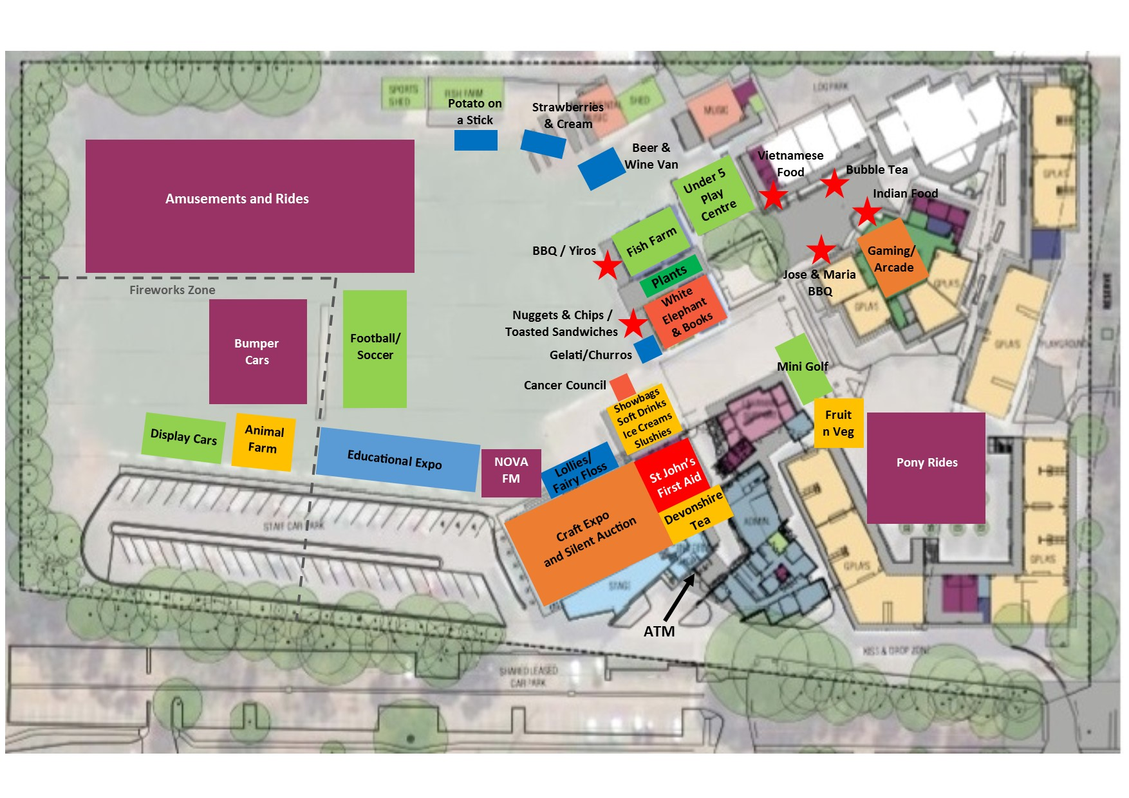
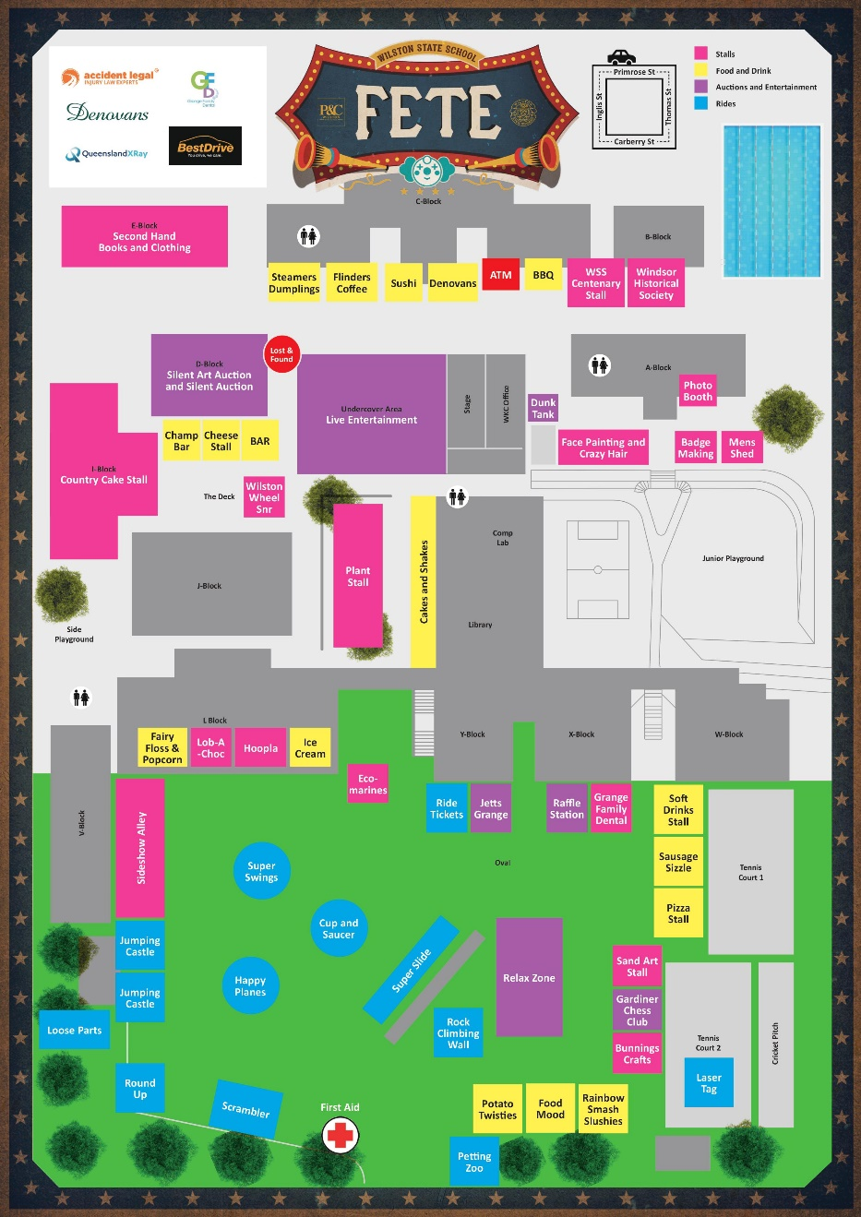

INCIDENT MANAGEMENT PLAN
Ensure the Incident Control Centre / Location of First Aid is clearly marked on your Site Plan.
Ensure exit / evacuation points and fire extinguishers are clearly marked on the site plan.
How will communication be conducted on the day of the event with event officials?

How will communication be conducted with the public?

How will communication be conducted in the event of an incident e.g. portable handheld radios / mobile phones?

Incident Management Contact Details
Name | Contact Details | Location
First Aid Officer 1:

First Aid Officer 2:

Incident Officer:

Other:

All Incident Reports are to be recorded using the Incident Report Form found in Appendix 3

MEDIA
In the event of any emergency occurring during the event, only the nominated representative will make or authorise statements or hold media conferences. The person nominated is XXXXX.

APPENDICES

Appendix 1: Emergency Response Procedure
Emergency Response Procedure
Where an incident occurs (a situation where control is lost and could cause harm (injury, illness or damage to people/property)) the person upon becoming aware of the incident must report through to XXXXXX – insert phone number.
INSERT INFORMATION THAT IS SPECIFIC TO THE EVENT AND LOCATION

Emergency Assembly Point
Option 1:
Option 2:

Appendix 2: Traffic Management Plan

INSERT SITE SPECIFIC DOCUMENT

Appendix 3: Incident & Investigation Report Form
Incident Report – Part 1
NOTIFIABLE INCIDENT – CERTAIN WORK RELATED INJURIES AND DANGEROUS OCCURANCES
Work Health & Safety Act 2012 notifiable incident means:
- The death of a person; or
- A serious injury or illness of a person; or
- A dangerous occurrence

Is this accident / incident / near miss a Notifiable Incident? Yes No
Contact: CSH&W SA (8215 6850 After Hours (0417 534 020) Yes
Worksite Officer Yes
The person with management or control of a workplace must so far as is reasonably practicable, preserve the incident site until an inspector attends the site, or directs otherwise.
- TYPE OF INCIDENT
 | Environmental |  |  | Property Damage/Loss |  |  |  | Hazard
 | Security |  |  | No Injury |  |  |  | Physical Injury
 | Non-Conformance Report |  |  | Complaint |  |  |  | Notice of Entry
 | Psychological Injury |  |  | Student Injury |  |  |  | Bullying involving manager
 | Bullying NOT involving manager |  |  | Client / Resident Injury |  |  |  | Client Resident or Student No Injury
 | Data Breach |  |  | Restrictive Practice
Short description of incident (include any injuries):
- PERSON/S INVOLVED IN INCIDENT
Full Name: |  |  |  |  | Contact Number:
Employee Client Visitor Volunteer Contractor Self-employed Other
- PERSON REPORTING THE INCIDENT
Full Name:
- INCIDENT REPORTED TO
Full Name:
- INCIDENT WITNESSED BY
Full Name: |  |  |  |  | Contact Number:
- LOCATION DETAILS
Work Site: |  |  |  |  | Exact Area:
Date of Incident: |  | Date Reported: |  |  |  | Time Reported:
- INCIDENT DETAILS

- INJURY REPORT (if no injury, go to Question 9)
8.2 Injury Classification
Nature of Injury
 | Amputation and/or Eye Loss |  | Muscle, Tendon or Soft Tissue Disorder
 | Damage to artificial limbs |  | Hernia
 | Foreign Body - eye respiratory or digestive system |  | Infectious or Parasitic Disease
 | Internal Chest, Abdomen, & Pelvis |  | Cancer or other Neoplasm
 | Nerve and Spinal Cord |  | Contusion and/or crushing
 | Sprains & Strains |  | Effects of External Exposure - weather air pressure etc
 | Eye Disorder (non-traumatic) |  | Fracture not including spine
 | Dermatitis and other Eczema |  | Multiple Injuries
 | Diseases of the Digestive System |  | Poison & Toxic Effect
 | Circulatory System Disease |  | Deafness
 | Burns and scalds |  | Musculoskeletal Disease
 | Dislocation |  | Disease of Skin and Subcutaneous Tissue
 | Fracture including spine |  | Respiratory System Disease
 | Internal Head Injury including concussion |  | Mental Disorder
 | Open Wound |  | Superficial Injury
 | Other
Bodily Location of Injury
 | Eye |  |  |  | Shoulders and arms
 | Ear |  |  |  | Hands and Fingers
 | Face |  |  |  | Hips and legs
 | Head (other than eye, ear and face) |  |  |  | Feet and toes
 | Neck |  |  |  | Internal Organs
 | Back |  |  |  | Multiple locations (more than one of the above)
 | Trunk (other than back & excluding internal organs) |  |  |  | Other
Injury Description

Mechanism of Injury
 | Bites or Stings |  |  | Fall from height
 | Contact with electricity |  |  | Hit by moving object
 | Exposure to variations in pressure (not sound) |  |  | Long term exposure to sound
 | Fall on same level |  |  | Repetitive movement with low muscle loading
 | Hitting object with body |  |  | Slide or cave in
 | Muscular stress |  |  | Vehicle accident
 | Sharp sudden sounds |  |  | Client/Resident
 | Exposure mental stress |  |  | Student
 | Fall from Different Level |  |  | Exposure to mechanical vibration
 | Heat and cold contact or exposure |  |  | Contact or exposure to biological factors
 | Long term contact with chemical or substance |  |  | Single contact with chemical or substance (not bite or stings)
 | Radiation exposure |  |  | Other or multiple mechanism
8.3 First Aid
First Aid Given? |  | Yes |  |  | No
Given By:
Description:
Outcome:

- IMMEDIATE ACTIONS

- DISTRIBUTION LIST
WILL BE LISTED ON INCIDENT DATABASE
Please forward this Incident Report to your WHS Coordinator, Risk & Compliance Officer, or delegated personnel for further Investigation.
Investigation Report - Part 2
- INVESTIGATION TEAM
WILL BE LISTED ON INCIDENT DATABASE

- INVESTIGATION DETAILS
Details of Incident | WILL BE LISTED ON INCIDENT DATABASE
Incident Date: |  | Date Reported:
Investigation Details
Investigation Files | Attach supporting investigation documents

- INTERVIEWS
Attach details of any interviews that are conducted.

- EXTERNAL NOTIFICATION REQUIRED
Was External Notification Required? | Yes | No
Has a Worker’s Compensation claim been lodged? | Yes | No
RRTWC Contacted? | Yes | No
Attach any supporting documents.

- POTENTIAL RISK OF INCIDENT
Consequences that could occur from the incident |  |  | Likelihood of the incident occurring
1 | Insignificant | First aid treatment | A | Rare | Hasn’t occurred
2 | Minor | Medical Treatment | B | Unlikely | Has occurred
3 | Moderate | Significant non-permanent injury | C | Possible | Occasionally occurred
4 | Major | Permanent Injury | D | Probable | Occurred several times
5 | Catastrophic | Death / Permanent disabling injury | E | Almost Certain | Has occurred often
Risk Assessment Matrix |  |  | LIKELIHOOD
 |  |  | Rare | Unlikely | Possible | Probable | Almost Certain
 |  |  | A | B | C | D | E
CONSEQUENCES | Catastrophic | 5 | Medium 11 | Medium 16 | High 20 | High 23 | High 25
 | Major | 4 | Low 7 | Medium 12 | Medium 17 | High 21 | High 24
 | Moderate | 3 | Low 4 | Low 8 | Medium 13 | Medium 18 | High 22
 | Minor | 2 | Low 2 | Low 5 | Low 9 | Medium 14 | Medium 19
 | Insignificant | 1 | Low 1 | Low 3 | Low 6 | Low 10 | Medium 15
Risk Level | Risk Score | Timeframe for Implementation of Control Measures
High | 20 - 25 | Act Immediately or within 24 hours to lower the risk to an acceptable level or as low as reasonably practicable.
Medium | 11 - 19 | Act within 21 days to reduce the risk to an acceptable level or as low as reasonably practicable.
Low | 1 - 10 | Act within 60 days to reduce the risk to an acceptable level or as low as reasonably practicable.
Note: a higher risk number means a higher priority within that risk level (e.g. a Low 10 is higher priority than a Low 1).

- ROOT CAUSES
Management System:
Environment:
Plant / Equipment / Tools:
Human Factors / Behaviour:
Job / Task / Materials:
Other:

- CORRECTIVE ACTIONS
Details:
Assigned To: | Due Date:
Details:
Assigned To: | Due Date:
Details:
Assigned To: | Due Date:

- DISTRIBUTION LIST
WILL BE LISTED ON INCIDENT DATABASE

Appendix 4: Risk Assessment

Event Organiser to include event risk assessment

