**Emergency Shower & Eyewash Guidelines**

**KEY ASPECTS OF EMERGENCY SHOWER / EYEWASH UNITS**

* Emergency Shower / Eyewash units are to be located a maximum of 10 seconds travel to them from any area where substances are used that if contact with a person occurs, would require the use of emergency facilities.
* If travel time to an emergency shower / eyewash is greater than 10 seconds, then in room facilities will be required e.g. tap with flexible hose and emergency eyewash bottles/station (refer examples below).
* Emergency Showers / Eyewash units are to be inspected and tested **monthly**. (CSHWSA have undertaken assessment and determined that the weekly checks can be done monthly and this timeframe is reasonable). Monthly testing should use ‘Monthly Emergency Shower & Eyewash Inspection Checklist’ – ***link to be included when or if in place***
* Monthly testing is to be recorded on the [**Safety Shower & Eyewash Testing Form (060F)**](https://www.cshwsa.org.au/download/1108/)or equivalent, including name and signature of the tester.
* Plumbed Emergency Showers / Eyewash units are to be inspected and tested **yearly** (flow test). This can be done by a competent person. An annual test record tag (example below) must be affixed to plumbed emergency shower / eyewash units to record the yearly flow tests.

**Annual Flow Test Record Card Example**

**Portable Emergency Eyewash Sink with Flexible Hose**

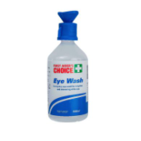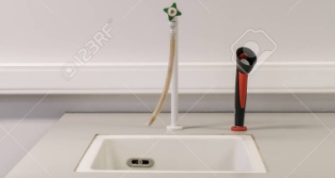

**MONTHY TESTING**

* Routine inspections / tests are most effectively conducted by 2 persons.
* Testing should use ‘Monthly Emergency Shower & Eyewash Inspection Checklist’ – [***Safety Shower & Eyewash Testing Form***](https://www.cshwsa.org.au/download/1108/)Sites should purchase a tester sock (refer examples below) to undertake the monthly testing.
* Shower / eyewash is to be activated for a period long enough to verify operation and ensure water is available and clean (minimum 3 seconds). If water is not clear, continue operation until water is clear. This flushing helps clean out any rust, scale deposits, or bacteria that may accumulate and cause additional injury, along with ensuring the regular operation of mechanical valves.
* When testing the eyewash, ensure dust caps are in place and when operated these pop off with the flow of water.
* Aside from the operation of the equipment (water flow), checks need to include overall condition, signage, unobstructed access refer ‘Monthly Emergency Shower & Eyewash Inspection Checklist’ – ***link to be included when or if in place***.
* If the shower / eyewash station fails to operate, water flow is intermittent or if defective apparatus is found during the test, action is to be taken to have the problems fixed as a matter of priority. Tag the shower/eyewash station as ‘Out of Service’ and notify the relevant site person.
* Ensure any spills are cleaned up.
* Record your inspection/test on 060F or equivalent.

 **Equipment Testing Shower Testing Eyewash**



**ANNUAL TESTING – Plumbed equipment**

* This is a flow rate test and is to be completed by a competent person.
* The flow rate should be 210 kpa
* If the shower / eyewash station fails to operate, water flow is intermittent or if defective apparatus is found during the test, action is to be taken to have the problems fixed as a matter of priority. Tag the shower/eyewash station as ‘Out of Service’ and notify the relevant site person.
* Ensure any spills are cleaned up.
* Record your inspection/test on the annual flow test record card.

**Minimum testing requirements:**

* Showers - 75.7 litres per minute (1.3 litres/second, 6.5 litres/5 seconds, 13 litres/10 seconds, 39 litres/30 seconds).
* Eyewash - 1.5 litres per minute.
* Eye/face wash combination - 11.4 litres per minute.
* Drench hose - 11.4 litres per minute.