Workstation Exercises
Stop, get up and move
The key to preventing overuse injuries is to break repetitive work with non-repetitive tasks or exercises and/or rest breaks. Getting up and walking around is the best exercise you can get to provide a break from sitting, concentrating and suing the muscles of the arms and hands. About every 20 to 30 minutes is a guide to how often it is helpful to move around.
Even getting up for 20 to 30 seconds to pick up papers from the photocopier or get some water is a way to change your posture and give muscles a chance to recover.
S-t-r-e-t-c-h and check!
Stretching exercises help to relax muscles which have been working and move those which have been in a fixed position. If possible, stand up to do your stretches.
While you are exercising, read the notes alongside each instruction and consider whether your workstation is adjusted to suit you.
- Do a few of these exercised several times every day.
- Dots show the muscles that you are exercising.
- Make sure you relax and perform them gently.
- Hold the stretch or repeat as indicated on the diagram.
- Do not over-stretch.
- Stop if you feel discomfort when performing an action.
- Refrain from doing these exercises if you have a medical condition that could be made worse by stretching – check with your health care professional.
- Remember to do each side.
Neck
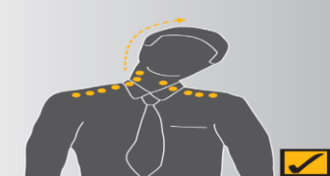  Figure 1. Neck stretch |  | Neck stretch  Keeping your chin tucked in, gently lower ear to shoulder and hold for 10 seconds on either side. Repeat several times. See Figure 1.  Head turns  Turn head slowly to look over left shoulder. Turn head the other way. Repeat several times. See Figure 2.  Chin tucks  Raise the head to straighten the neck. Tuck the chin in and upwards creating a double chin. This also results in a forward tilt of the head. Repeat several times. See Figure 3.  Check neck posture  - Position the top of your screen at eye level.  - Use a document holder directly beside or below the screen – it saves you looking down.
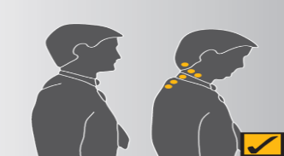
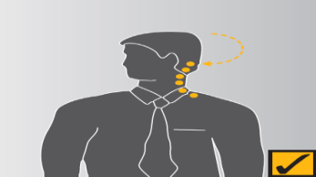
Figure 2. Head turns
Figure 3. Chin tucks
Shoulders
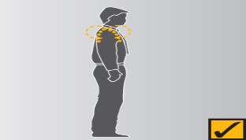  Figure 4. Shoulder rolls | Shoulder rolls  Circle shoulders forward several times, then backwards. Repeat 3 to 5 times. See Figure 4.  Check shoulder posture  Relax your shoulders and rest your hands on your lap. Bend your elbows to no more than 90 degrees and check the height of your finger tops against your current work height. If the work (keyboard or desk) is higher than your hands you may be hunching yours shoulders unnecessarily. If so, try and raise your chair height or lower your desk height and try and relax your shoulders while working.
Wrists, hands and arms
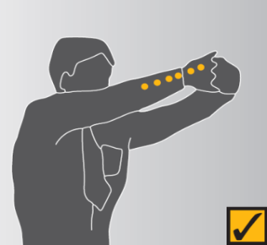  Figure 5. Wrist and elbow stretch | Wrist and elbow stretch  Interlace fingers, palms outward, and straighten arms in front. Hold for 10 seconds and repeat several times. See Figure 5.  Wrist stretch  Straighten your arm in front and bend your wrist forward, gently assist the stretch with your other hand. Hold for 10 seconds then stretch your wrist back and hold for 10 seconds. Repeat with other arm. See Figure 6.  Check hand and wrist posture  - While keying, keep your wrist straight while your fingers are suspended over the keyboard.  - Keep elbows at keyboard level. This may mean adjusting the desk or chair height.  - Don’t rest your wrists on the desk or keyboard while keying. Keep hands suspended.  - Rest on the desk between periods of keying.
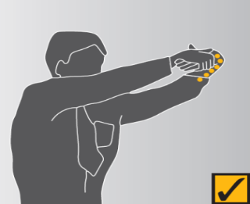
Figure 6. Wrist stretch
Upper and lower back
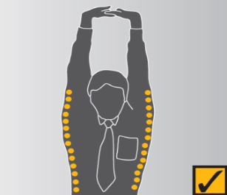  Figure 7. Upper and lower back stretch | Upper and lower back stretch  Interlace fingers and turn palms upwards above head; straighten arms then slowly lean slightly from side to side. Repeat movement several times. See Figure 7.  Back arching  Stand up. Support your lower back with hands and gently arch back and hold for 5 to 10 seconds. Repeat as often as needed. See Figure 8.  Pectoral stretch  Raise both arms to shoulder height and bend elbows. Pull both elbows back slowly to bring shoulder blades towards each other. Repeat several times. See Figure 9.  Check back support  - Sit well back in your chair – if your feet need support, use a footrest.  - Adjust the backrest on your chair to support your lower back.
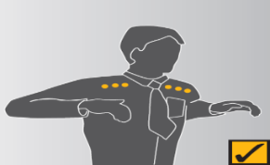
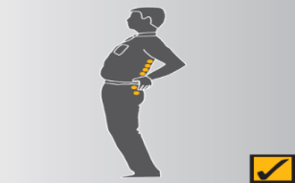
Figure 8. Back arching
Figure 9. Pectoral stretch
Legs
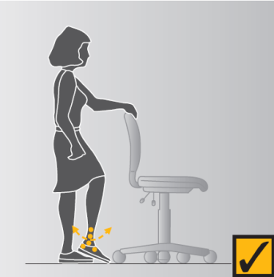  Figure 10. Foot pump | Foot pump  Stand up, holding the chair for balance if necessary, and alternatively raise heels and toes. Repeat 10 times. See Figure 10.  Check leg comfort  - If the seat of your chair is digging into the backs of your thighs check that it is not too high or whether it is tilted backwards.  - If the seat is too high, lower the chair and desk or use a foot rest to support your feet.  - Also check the tilt of the seat and, if necessary, adjust it to a horizontal position.
Eyes
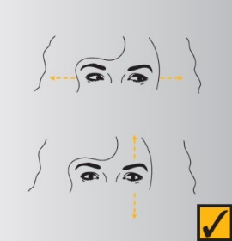  Figure 11. Eye exercise | Eye exercise  Sit up straight, face forward and repeat this sequence several times without moving your head. Look up, then down. Look left, then right. See Figure 11.  Visual rest  Look up and away from the screen. Focus on a distant object (more than 3 meters away). For example, look out of the window or at a picture on a far wall. Shift vision back to screen and refocus. See Figure 12  Check eye comfort  - Is there enough light falling on your documents?  - Do windows or light fittings cause glare or reflection on the screen? If so, try turning the screen or blocking the path of the light.  - Use a screen with a light background when working with text.
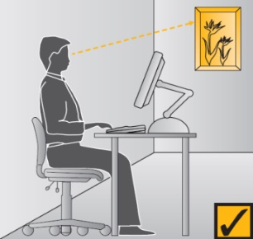
Figure 12. Visual rest

