Lock Out/Tag Out Guideline
If access is required for the purpose of maintenance, cleaning or repair, the item of plant must be stopped and one or more of the following controls used to minimise any risk to health or safety:
- Lockout or isolation devices;
- Danger tags;
- Permit to work systems;
- Other control measures.
Isolation Procedures
The isolation procedure should be as follows:
- Identify all power sources and isolate them;
- Lock or otherwise secure all isolating points using padlocks, multi-padlock hasps (refer to picture 1) and danger tags (refer to picture 3);
- Dissipate all stored energy. This may include ensuring inertia in mechanical parts, parts likely to move by gravity, electrical capacitors, accumulators, springs and pressurised fluids;
- Verify that the isolation is effective;
- Identify the safe area of work.
Out of Service Tags (Picture 2)
These are used to identify equipment or machinery that has been taken out of service due to a fault, damage or malfunction. The tag is to be securely fixed to the operating control power isolator with the appropriate details completed on the tag (explaining the reason for the machine being ‘out of service’). The tag should not be removed until the equipment is safe to be returned to service, or the reason for the tag no longer exists.
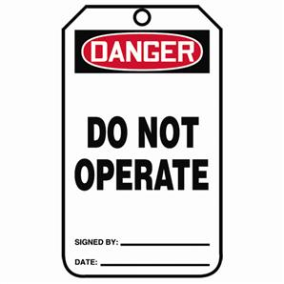
It may be removed by:
- the person who attached the tag
- the supervisor responsible for the operation or repair of the equipment
- the maintenance person who carried out the repairs
Personal Danger Tag (Picture 3)
- Any person required to perform work on the equipment will install their own completed ‘Danger’ (white) tag to the isolation point.
- Where danger tags are required, individuals must place tag at the start of a job and remove the tag at the finish of the job or at the end of the work period/shift.
- Tags should be dated and signed.
- The tag must only be removed by the person whose name is on the tag or by the Supervisor after consultation with the signatory on the tag
- Illegal removal of a danger tag is regarded as a serious breach of safety regulations.
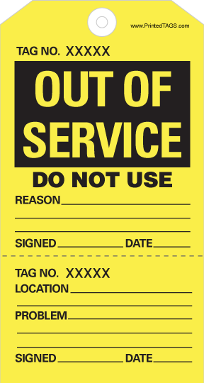
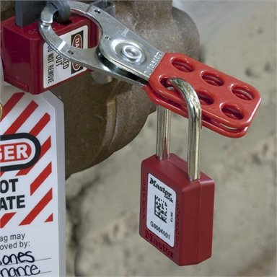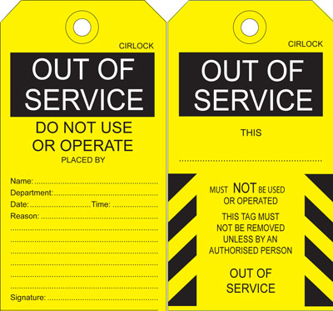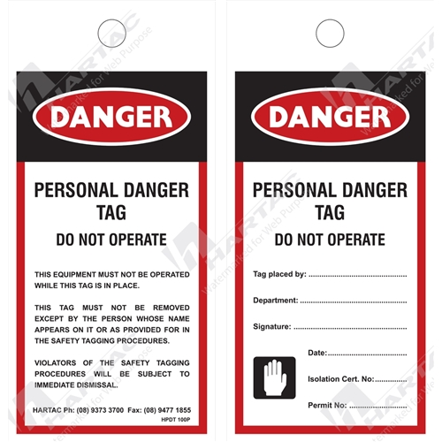
Picture 1. | Picture 2. | Picture 3.

