Assembly Area
Fire Hydrant
Fire Blanket
First Aid
Fire Hose Reel | 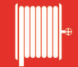
Water Extinguisher | 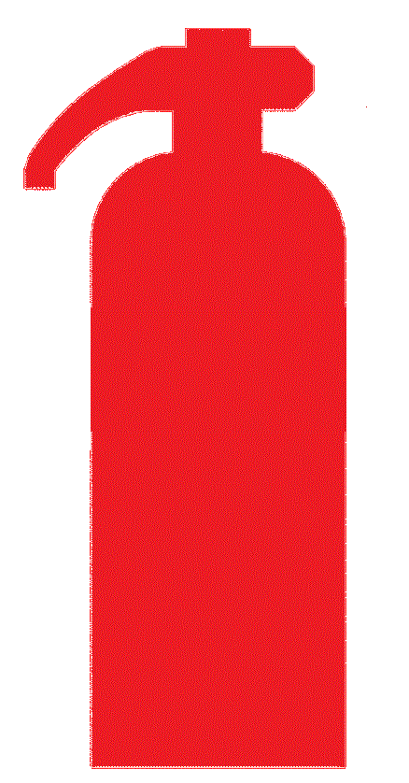
CO₂ Extinguisher | 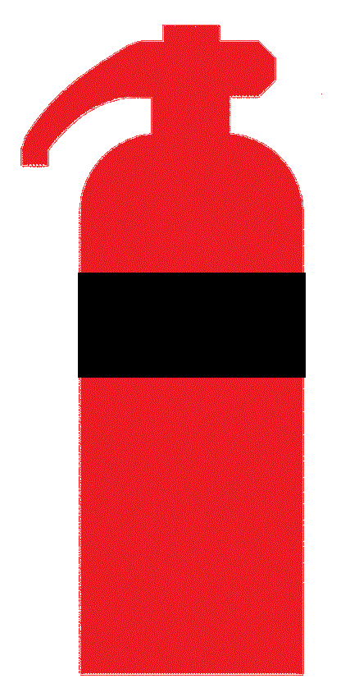
Dry Chemical Powder Extinguisher | 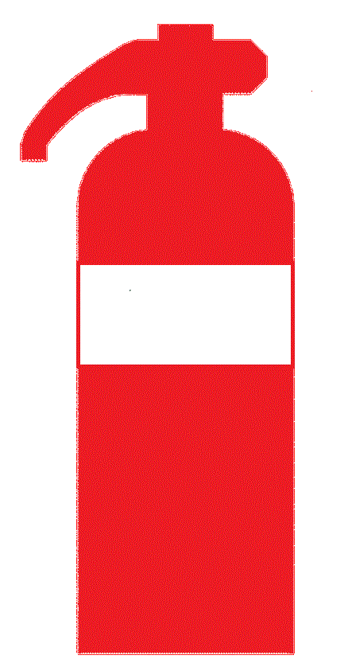
Foam Extinguisher

Wet Chemical Extinguisher

Emergency Exit

You are here

Manual Call Point

Automated External Defibrillator | 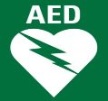
Emergency Contact

North

