Site / Area: |  |  |  | Date of assessment: |  | Risk Assessment #: | 017RA
Completed by (name): |  |  |  | Signature:
In Consultation with |  |  |  | Signature:
Identify / describe activity, equipment, area or event you are assessing: |  |  |  |  | Trailer BBQ
 | Step 1: Identify the hazard/s:  What do you believe are the hazards?  (Refer Risk Assessment Guideline (015G)) |  | Step 2: Assess the risks:  What do you believe are the risks?  (Refer Risk Assessment Guideline (015G)) |  | Step 3: Reducing the risk:  What do you believe can be done to reduce the risk?  (Refer Risk Assessment Guideline (015G))
 | What could cause harm? |  | What could go wrong? |  | Controls
 | Machinery & Equipment  - Trailer |  | - Trailer could dislodge causing accident  - Trailer could suffer mechanical failure  - Flying projectile in the vehicle if not secured properly. |  | Trailer certified to approved safety standards.  Trailer is roadworthy and registered.  Trailer has been serviced in the last 2 years.  Check vehicle gross towing weight to trailer.  Vehicle to be reversed to the tow ball and then lower the trailer connection onto it. Check the mechanical connections. Check and ensure indicator & brake lights are working correctly. Safety chain is used.  All items on trailer itself to be checked to ensure they are secured prior to moving.  Tyre pressures to be checked prior to moving.  Only licensed driver, with trailer towing experience to drive vehicle towing the trailer. Driver to obey road traffic rules.
 | Hazardous Chemicals  - LPG  - Transport of cylinders  - Cylinders  - BBQing |  | - Gas leak  - Projectiles (foreign body in eye, penetrate skin etc.)  - Explosion  - Asphyxiation  - Fire |  | - Cylinder to stand upright at all times. Cylinders not to be exposed to heat and DO NOT leave in an enclosed vehicle in direct sun for extended period of time.  - Cylinders to be secured from movement.  - Tap to be securely closed when being transported or not in use  - Gas cylinders checked and date stamped within last 10 years (check neck bottle for date stamp).  - Gas safety gauge installed between cylinder and hose (refer below).  - Tall portable gas cylinders must be secured both top and bottom by ropes or chains to a structural post, wall, or similar anchor point.  - Small portable BBQ gas cylinder to be secured to either the BBQ, a small star dropper or placed in a metal container  - Area to be designated as a “no smoking” or “no naked flame” area where cylinders are stored and are in use.  - Cylinders are not to be connected or disconnected in the vicinity of a naked flame.  - Area around BBQ to be kept clear.  - DO NOT use BBQ indoors or in a confined space.  - BBQ to be set up in well ventilated area.  - Hoses checked before use to ensure no gas leaks (e.g. spray soapy water on any suspect connections or hose and watch for bubbles. If bubbles appear, do no use. Check fittings at both ends and condition of hose).  - Fire extinguisher or access to water hose made available.  - Remove excess fat from BBQ after each use.  - Use appropriate gas lighter or long match stick to light BBQ.  - BBQ is to be used by adults only and whilst flame is on and is not to be left unattended.  - When not in use, gas to be turned off at the cylinder.  - For further information on safe use please refer to checklist below from Office of the Technical Regulator.
 | Extreme Temperatures  - Outside weather conditions  - Heat from BBQ |  | - Burns, scalds |  | - Long sleeved clothing or gloves to be worn.  - Long handled BBQ utensils with heat insulation to be used.  - If wearing an apron, use material apron NOT a plastic one.
 | Airborne Contaminants  - Smoke  - Gas |  | - Smoke inhalation |  | - DO NOT use BBQ indoors or in a confined space. BBQ to be set up in well ventilated area.
 | Hazardous Manual Tasks  - Moving Gas Bottle  - Moving Trailer |  | - Sprains / strains |  | - Use a trolley to move gas bottles where moving over distance  - If trailer requires moving make sure jockey wheel is down and two persons are used.
 | Biological  - Food hygiene  - Waste management |  | - Food poisoning  - Slips, trips & falls  - Pests/rodents around the area. |  | - Food to be stored off the ground.  - Food must be protected from dust, insects and any other sources of contamination.  - Meat to be stored at appropriate temperatures (cold) until cooked  - Disposable gloves to be worn when handling food.  - Tongs to be used.  - Meats / sausages to be properly cooked prior to serving. To be kept at an appropriate temperate for serving.  - Salads to be kept cool until serving.  Access to hand washing facilities &/or sanitiser (hand gel) made available.  - Where a person is suffering from vomiting, diarrhoea, stomach cramps or a food borne illness, they must not handle the food.  - Determine workflow to reduce cross-contamination (e.g. 1 person food preparation and another collecting money).  - Appropriate number of bins available.  - Recycling bins made available.  - NO glass bottles to be used.
 | Other  - Injury Management |  | - Any injury |  | - Current and complete First Aid kit is available.  - Current Senior First Aider is in attendance.  - In event of an emergency call 000.  Where possible an Automatic External Defibrillator (AED) is available. In the event the AED is used, this must be reported to CSHWSA ASAP.
 | Other
Outdoor gas appliances should never be used indoors
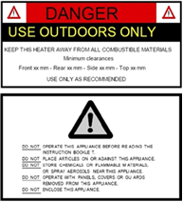
Most barbecues and portable camping equipment are designed and certified to be used outdoors in highly ventilated areas. If a gas appliance has been marked "for outdoor use only" you must not use it inside.

Barbecue warning label example

Maintaining your gas barbecue and LPG cylinder
- Before you use your gas barbecue and LPG cylinder you should carry out the following safety checks to ensure they are in good condition and safe to use.
- If using LPG, is the LPG cylinder in date? Cylinders should be safety tested every 10 years and this date is stamped on either the collar, neck or foot ring of the cylinder. Never use rusty or damaged cylinders.
- Don't use the appliance if the burners are blocked, rail taps are seized or the flexible hose is brittle, cracked or damaged. If unsure, seek the help of a licensed gas fitter.
- Always before use, check the condition of the hose for signs of cracking, kinking, crushing or stretching. When not in use, protect the hose from heat, sun exposure and physical damage.
- It's good practice to replace hoses every five years.
- Ensure hose assemblies are certified. The certification details will be printed on the hose.
- Ensure the regulator and hose are connected tightly to the cylinder and the appliance so there are no leaks.
- Check all exposed joints for leaks with a diluted solution of detergent and water. This can be done by using a spray bottle and spray it on all connections including the gas cylinder, valve, regulator joints and hose. If bubbles appear anywhere there is a gas leak. Immediately isolate the gas and have the fault repaired by a licensed gas fitter or replace the faulty component.
- It is recommended that gas barbecues are checked every two years by a licensed gas fitter. They can repair or replace the parts and ensure the appliance is performing safely and efficiently.
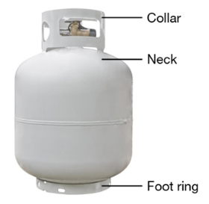
- Always keep barbecues clean of grease and oil to prevent a fire.

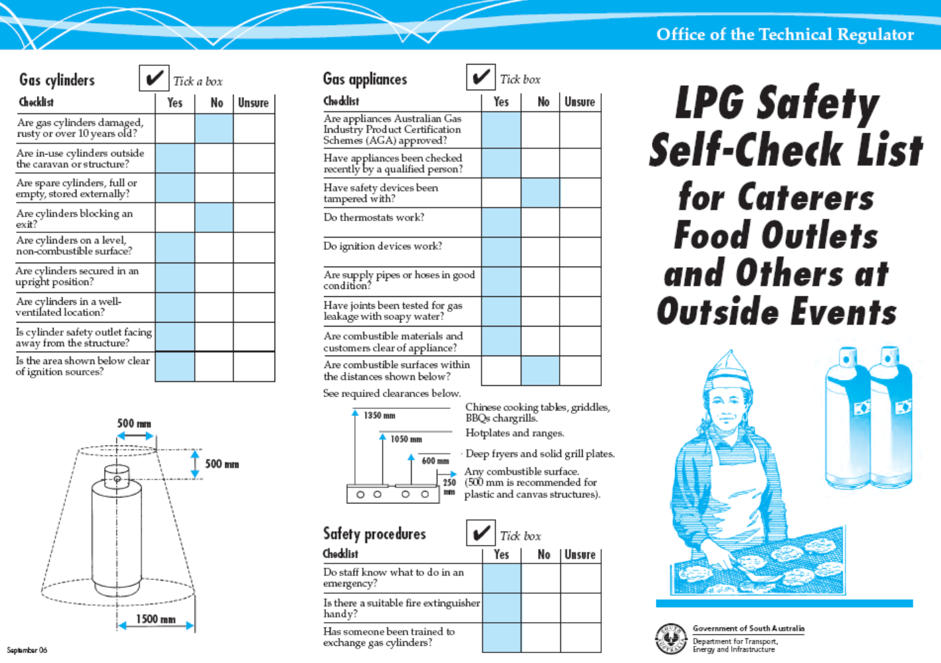

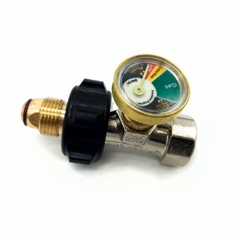
BBQ Gas Safety Gauge

A Gas Safety Gauge is an all in one gas safety device. It's easy to fit and easy to use. Designed for use with LPG type gas and cylinders, commonly used with barbeques, outdoor heaters, caravans etc. They come as just the gauge or a combination of gauge, regulator and hose.
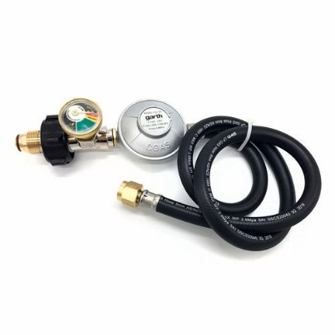
A Gas Safety Gauge is a handy, low cost, all in one gas safety device that shows gas cylinder level at a glance, detects leaks and automatically shuts off the flow of gas in the event of a major leak.
How to fit Gas Safety Gauge
You must read the full instructions and information supplied with the product prior to installation and use.

Authorised by: |  | Signature: |  | Date:
Review hazard/risk assessment if task or circumstances change and at intervals appropriate to the level of risk (minimum 5 years).

Step 4: Monitor & review:
(Refer to hazard sheet)
Please tick Yes or No
Were the controls effective? |  |  |  | Were there any unforeseen hazards/ incidents? |  |  |  | New controls
Yes |  | No |  | Yes |  | No
DETAILS |  |  |  | DETAILS |  |  |  | DETAILS
Name: |  | Signature: |  | Date:

