Site / Area: |  |  |  | Date of assessment: |  | Risk Assessment #: | 075RA
Completed by (name): |  |  |  | Signature:
In Consultation with |  |  |  | Signature:
Identify / describe activity, equipment, area or event you are assessing: |  |  |  |  | Scaffold (portable)
 | Step 1: Identify the hazard/s:  What do you believe are the hazards?  (Refer Risk Assessment Guideline (015G)) |  | Step 2: Assess the risks:  What do you believe are the risks?  (Refer Risk Assessment Guideline (015G)) |  | Step 3: Reducing the risk:  What do you believe can be done to reduce the risk?  (Refer Risk Assessment Guideline (015G))
 | What could cause harm? |  | What could go wrong? |  | Controls

NOTE: Scaffolding above 4 metres from ground level in height must be assembled by a licenced scaffolder.

This means if you are using a 4m Portable Scaffold on a level that is higher than ground level a licenced scaffolder must erect it.
In conjunction with this risk assessment, training / education and development of a relevant SOP may be required.
 | Electricity  - Scaffold coming into contact with live power  - Live power lines too close to work area. |  | - Electric shock / electrocution |  | - Earth Leakage Switch not installed on mains supply or portable generator.  - Working too close to live power lines.  - Scaffold components or materials handled are greater than 4 metres in length.  - Tiger Tails (insulation) not in place on power lines or wet conditions make them ineffective.  - Do not use the portable scaffold within 8 meters of power lines  - High wind causes power lines to swing closer to work area.  - Scaffold component strikes and shatters unprotected light bulb.
 | Extreme temperature  - Working outdoors |  | - Sunburn  - Skin cancer  - Heat stress  - Muscular skeletal injuries |  | Wear appropriate UV protection. For example:  Clothing  Hats  Sun glasses  Sunscreen  - Drink plenty of fluids during warm temperatures.
 | Gravity  - Fall from height  - Falling objects  - Uneven surfaces  - Uneven ground  - Inappropriate footwear |  | - Severe injuries  - Fractures  - Concussion, death  - Collapse of structure  - Injured by falling object |  | Always ensure the portable scaffold is level before use.  - Ensure portable scaffold has load rating placard and the load limits are not exceeded.  Use the portable scaffold on hard level surfaces.  - Distribute the load by placing boards underneath the portable scaffold.  - Ensure the wheels are locked before climbing.  - Ensure the ladder is securely hooked over the frame correctly before climbing. The ladder is designed to hook onto the frame between the end of the grip planks.  - Do not lean the ladder against the portable scaffold.  - Do not climb the frame of the portable scaffold.  - Ensure the area around the portable scaffold is bunted off.  - Erect caution sign  - Kickboards fitted to scaffold
 | Hazardous manual tasks  - Musculoskeletal injuries |  | - Strains, sprains.  - Hernia  - Spinal and neck damage |  | Where possible always use 2 people to move the portable scaffold.  - Correct manual handling techniques  Assemble the portable scaffold on hard level surfaces.  Where possible always use 2 people to assemble.  Wear gloves and fully enclosed shoes (steel caps are preferable).  Do not use a hammer on the frames. The frames are designed to fit tight for stability.  A rubber mallet is acceptable to use on the crossbars to assist with assembly.  - Following the Manufacturer’s instructions
 | Other:  - Inadequate training, consultation, planning and improvisation. |  | - Injury due to inexperience or failure to provide or use appropriate equipment |  | - Insufficient skills (competency) to complete the required task correctly.  - Inadequate consultation with relevant employees.  - Competent person not used for scaffold erection up to 4 metres in height.  - Certificated scaffolder not used to erect scaffold in excess of 4 metres in height or where complex configurations are involved.
 | - Unstable scaffold due to lack of competency in erection. |  | - Injury due to scaffold collapse or partial collapse. |  | - Competent person not used for scaffold erection up to 4 metres in height.  - Certificated scaffolder not used to erect scaffold where the working platform exceeds 4 metres in height or if the scaffold has cantilevers or outriggers.  - Foundation or ground not suitable for mobile scaffold.  - Different scaffold systems mixed together. (mix and match problems)
 | - Overload of scaffold components. |  | - Collapse causing fall from height. |  | - Wrong type of scaffold used for the job.  - Scaffold components overloaded beyond design limits.  - Different scaffold systems mixed together. (mix and match problems).
 | - Unstable or incorrect erection of scaffold. |  | - Injury due to scaffold collapse or partial collapse. |  | - Competent person not used for scaffold erection up to 4 metres in height.  - Certificated scaffolder not used to erect scaffold where the working platform exceeds 4 metres in height or if the scaffold has cantilevers or outriggers.  - Foundation or ground not suitable for mobile scaffold.  - Different scaffold systems mixed together. (mix and match problems)
 | - Scaffold erected too close to power lines or completed scaffold is moved too close to power lines during use. |  | - Electric shock or electrocution. |  | - Earth Leakage Switch not installed on mains supply or portable generator.  - Working on or moving mobile scaffold too close to live power lines.  - Scaffold components or material handled are greater than 4 metres in length.  - Scaffold component or material contacts power lines. Insulation (tiger tails) not in place on power lines or wet  conditions makes them  ineffective.  - Strong wind causes power lines to swing closer to work area.
 | - Unsupported frames being erected at ground level. |  | - Frames fall over striking person erecting scaffold or other person close to the work area. |  | - Bracing or team member not used to support first frames.  - Foundation not level or unsuitable for mobile scaffold.  - Castor wheels not adjusted correctly or not locked.
 | - Incorrectly assembled first frames causing unstable scaffold base. |  | - Fall from completed scaffold or fall from scaffold during erection. |  | - Insufficient skills (competency) to complete the required task.  - Instructions are not provided or are not clear – print is too small and/or photocopy cannot be read.  - Scaffold poorly maintained – colour coding referred to in instructions is not visible on components.  - Base frame assembled upside down – castor wheels will not fit correctly.
 | - Climbing lightweight scaffold base frames during erection. |  | - Scaffold tips over causing fall. |  | - Climbing up the outside of the frame causing scaffold to tip sideways.  - Only one person used in frame erection.  - Foundation not level or unsuitable for mobile scaffold.
 | - Base frames not adequately braced or supported. |  | - Instability/ collapse of base frames causing fall. |  | - Scaffold distorts out of square due to plan bracing being left out.  - Insufficient diagonal bracing or bracing fixed incorrectly.  - Castor wheels not locked to prevent movement or lock/s broken.  - Foundation not level or unsuitable for mobile scaffold.  - Castor wheels not adjusted correctly when levelling the base frames.
 | - Scaffold used without following manufacturer’s instructions (e.g. indoor or outdoor specifications). |  | - Scaffold topples over causing a fall from height. |  | - General height of the light duty prefabricated aluminium mobile scaffold exceeds three times the minimum base dimension (ref AS/NZS4576).  e.g. a scaffold with base dimensions of 2.4m x 1.8m the height to the working platform should be no more than 5.4m.  - For a scaffold with a narrow base width of less than 1.2m the height of the light duty prefabricated aluminium mobile scaffold exceeds twice the base width (ref AS4576). e.g. a scaffold with a base of 2.4m x 1.2m the height to the working platform should be no more than 2.4m.
 | - Erection of working platform |  | - Sprains, strains and fractures. |  | - Only one person used to lift platforms onto second level frames.
 | - Edge protection incomplete. |  | - Fall from the edge of the working platform. |  | - Handrail not positioned 900 – 1100mm above the working platform on all sides.  - No mid-rail or fender board installed to all sides.
 | - Unsecured tools and/or equipment lying on working platform. |  | - Struck by falling object. |  | - No fender boards fitted to the working platform.  - No exclusion zone around scaffold positioned in a public or work area.  - Area around base of scaffold not barricaded or bunted off.
Authorised by: |  | Signature: |  | Date:
Review hazard/risk assessment if task or circumstances change and at intervals appropriate to the level of risk (minimum 5 years).
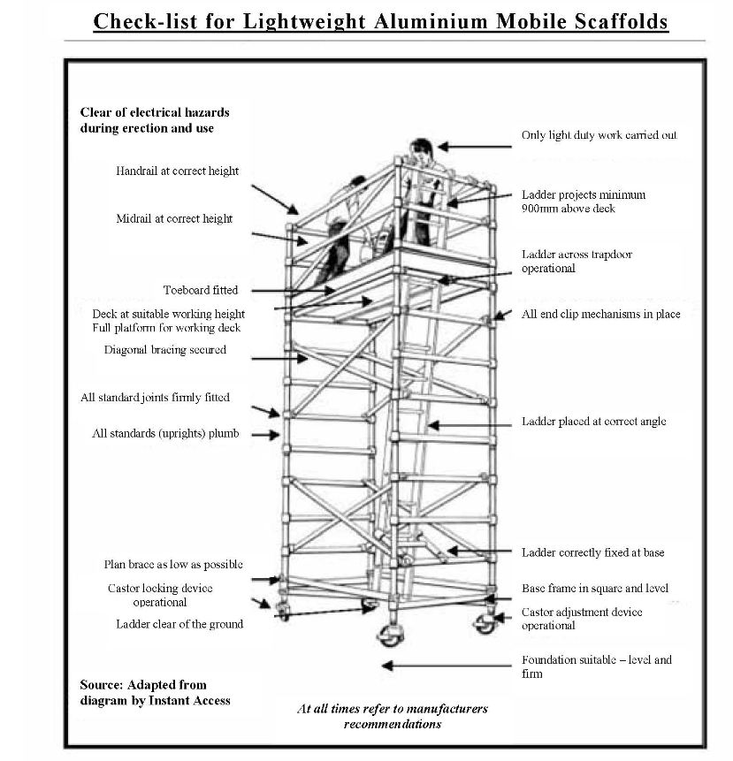
Step 4: Monitor & review:
(Refer to hazard sheet)
Please tick Yes or No
Were the controls effective? |  |  |  | Were there any unforeseen hazards/ incidents? |  |  |  | New controls
Yes |  | No |  | Yes |  | No
DETAILS |  |  |  | DETAILS |  |  |  | DETAILS
Name: |  | Signature: |  | Date:

